AS A MOTHER
- If I truly believed that my daughter had been abducted (Not that I would have left her in such a vulnerable situation in the first place.) I don't think that I could have left Portugal without LITERALLY “leaving no stone unturned”
- I would NOT have let my remaining children out of my sight - let alone put them back in the crèche at the complex from where my daughter was "abducted".
- I certainly would not have gone on a world tour.
- I would not have done a happy photo shoot with the twins. (What if my abducted daughter had seen this and been told by her "abductor" how happy my family were without her?)
- I would have sold my house in England to fund my stay in Portugal.
- If the public had been generous enough to donate money I would have told them exactly where the money was going.
- If I had been told by "experts" NOT to show emotion I could not have ever complied with that in a million years. I would have dragged my husband away from his computer when he was blogging to really SEARCH for our daughter.
- I would not have been seen leaving church on the Portuguese equivalent of Mothering Sunday looking like a visiting dignitary - smiling and waving to the crowds.
- When there were multiple reports of sightings of my daughter in Malta I would have been on the first plane there - or sent my husband.
- On the day that the Portuguese Police were digging and looking for a body after a tip off I would NOT have been popping off to the airport to collect visiting relatives/friends - the police would have had to stop me digging with my bare hands.
- If my husband had been organizing a rock concert to mark the anniversary of my daughter's abduction 2 weeks after she had disappeared I would have felt like doing him serious harm.
- When she disappeared I would have been running around the resort like a mad woman - not asking for a priest and praying.
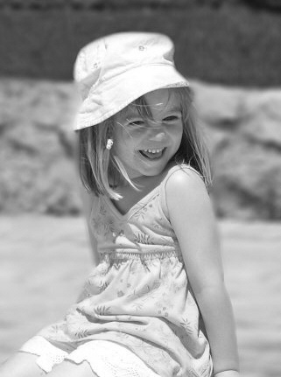
- I would release every picture of her taken in that week’s holiday as they were the most recent photographs of my daughter.
- I would tell my family members to stop criticising the police.
We need them.
Hey that's me - I love my child
For further information which the media refuse to discuss,
visit:-Internet

