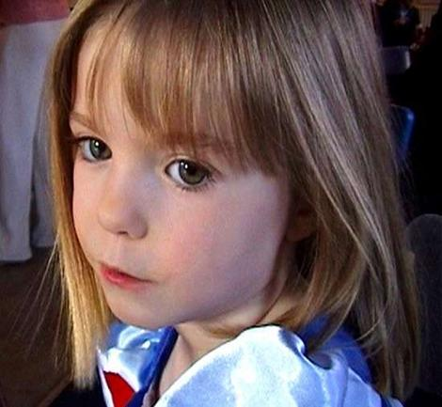
AS
A
MOTHER

If I truly believed that my daughter had been abducted (Not that I would have left her in such a vulnerable situation in the first place.)
I don't think that I could have left Portugal
without LITERALLY “leaving no stone unturned”.

I would have BEGGED the Portuguese Police for a reconstruction

I would NOT have let my remaining children out of my sight
- let alone put them back in the crèche
at the complex from where my daughter was "abducted".

I certainly would not have gone on a world tour.

I would not have done a happy photo shoot with the twins.
(What if my abducted daughter had seen this and been told by her "abductor" how happy my family were without her?)

I would have sold my house in England to fund my stay in Portugal.

If the public had been generous enough to donate money I would have told them exactly where the money was going.

If my husband had been photographed with a flip chart I would have shoved it where the ‘sun don't shine’.

If I had been told by "experts" NOT to show emotion
I could not have ever complied with that in a million years.
I would have dragged my husband away from his computer when he was blogging to really SEARCH for our daughter.

I would not have even wasted brain power organising
a kite flying day in Afghanistan.

I would not have been seen leaving church on the Portuguese equivalent of Mothering Sunday looking like a visiting dignitary
- smiling and waving to the crowds.

When there were multiple reports of sightings of my daughter in Malta
I would have been on the first plane there - or sent my husband.

On the day that the PJ were digging and looking for a body after a tip off I would NOT have been popping off to the airport
to collect visiting relatives/friends
- the PJ would have had to stop me digging with my bare hands.

If my husband had been organizing a rock concert to mark the anniversary of my daughter's abduction 2 weeks after she had disappeared I would have felt like doing him serious harm.

When she disappeared I would have been running around the resort like a mad woman - not asking for a priest and praying.

I would release every picture of her taken in that week’s holiday as they were the most recent photographs of my daughter.

I would tell my family members to stop criticising the police.
We need them.
Hey that's me - I love my child
For further information
Which the media refuse to discuss, visit:- Internet

