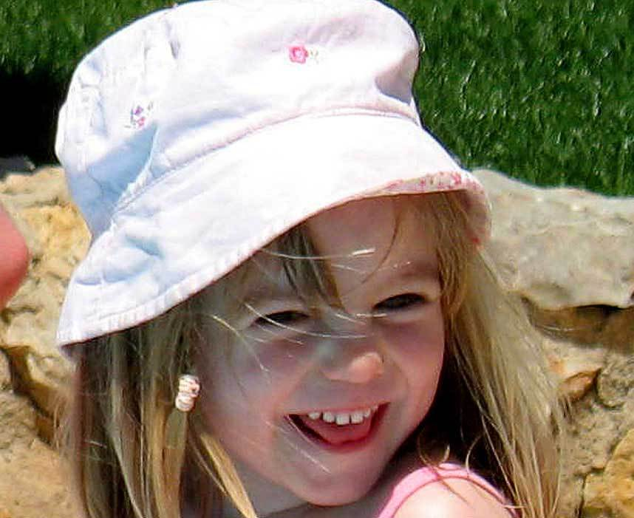
WHAT ARE THE CHANCES?
Of having your wallet, sports bag and your child all taken
- all in separate incidents?.
Of an abductor leaving no prints or DNA evidence?
Of a child being taken in the ONLY 5 minute
window of opportunity when there was nobody checking?
Of an abductor hiding behind a door that opens against a wall?
Of an abductor entering an apartment through the door and exiting through the window?
Of an abductor making his getaway on foot, carrying in his arms a sleeping child in her pyjamas?
Of Jane Tanner seeing a small print pattern on pyjamas that couldn't be made out when shown close up on TV?
Of people who leave children alone in an apartment also leaving doors unlocked, but forgetting they had when the issue of the abductor's entry is first raised?
Of a mother running away from the abduction scene, leaving two two-year-olds exposed to the very same abductor?
Of patio doors being left unlocked, yet the parents being adamant that the child had not merely wandered off?
Of it being a misunderstanding when someone in the group is asked to phone the police at 10.15pm but the police say the first call came in at 10.40pm?
Of the parents staying in the apartment while everyone else searched long into the night for the 'abducted' child?
Of the parents leaving the 2 two-year-olds in the care of the resort creche the next day - despite the fact that any member of staff could have been involved?
Of nine/ten people dining at the Tapas bar, and not ONE of them thinking that leaving their children/babies was wrong?
Of all the children, of all the families, falling asleep at approximately the same time, and of none of them waking up?
Of anyone leaving their child again when they told you they were crying for you when you left them the previous night?
Of NONE of the "Tapas 7" wearing watches or having their mobiles with them?
Of turning down a resort's offer of a free babysitter the same day of your child's abduction?
Of not taking your children to the restaurant with you because there was no buggy available?
Of a mother who said the "abductor" had moved cuddle cat, actually holding it and washing it when it could have had the "abductors" prints or DNA on it?
Of promoting the one distinctive feature, the eye defect that would surely endanger your child's life by making her value to a potential abductor too risky and too hot to handle? -Against the advice of the police?
Of the parents of an abducted child to keep always forgetting to mention the £2m reward for her safe return during their TV appeals?
Of the finger of suspicion being pointed at another (Robert Murat) by three of the group, until the likeness to one of the group was observed?
Of the parents not sacking a detective agency who endangered the life of their child by announcing her location and her imminent rescue - on two separate occasions?
Of the PJ and the British Police not finding any prints of the twins or Madeleine?
Of highly-trained forensic cadaver dogs from the UK being mistaken?
Of DNA results from a British laboratory being wrong?
Of Kate McCann being involved with 6 dead bodies in the week before the holiday?
Of Kate bringing "Cuddle Cat" to work with her and it thus acquiring the scent of death?
Of the Portuguese police offering a "deal" for which there is no provision under Portuguese Law?
Of a key witness, a close friend of the suspects, having lied in key testimony but NOT being in cahoots with the suspects?
Of getting a backer worth 350 million who offers a Government employee a job as your spokesman?
Of the parents setting up a website within one week, and registering Madeleine's eye defect as a trademark within 2 weeks of her disappearance?
Of innocent parents refusing to help the investigating police by answering questions and not immediately taking part in a reconstruction?

The combined police forces of two countries...
Ex-SAS officers...
30 private detectives...
The backing of several millionaires...
High-level Governmental intervention...
A blessing by the Pope...
A £2m reward on offer...
An unprecedented 'awareness' campaign...
A £1m 'fighting fund' donated by the public...
The unstinting support of the British media...
The involvement of Interpol...
The interest of the European parliament...
The support of White House officials...
The world's best sniffer dogs...
The world's most respected forensic scientists...
... and still not a single lead?
Still not a single clue turned up to enforce the claim of abduction?
WHAT ARE THE CHANCES?

To discuss this case, and media censorship of it visit Internet

